**Digital Signal Processing**

**Experiment 1: Generation of Basic Signals**

**Post – Lab Questions**

Derive the code and show the output for signum function.

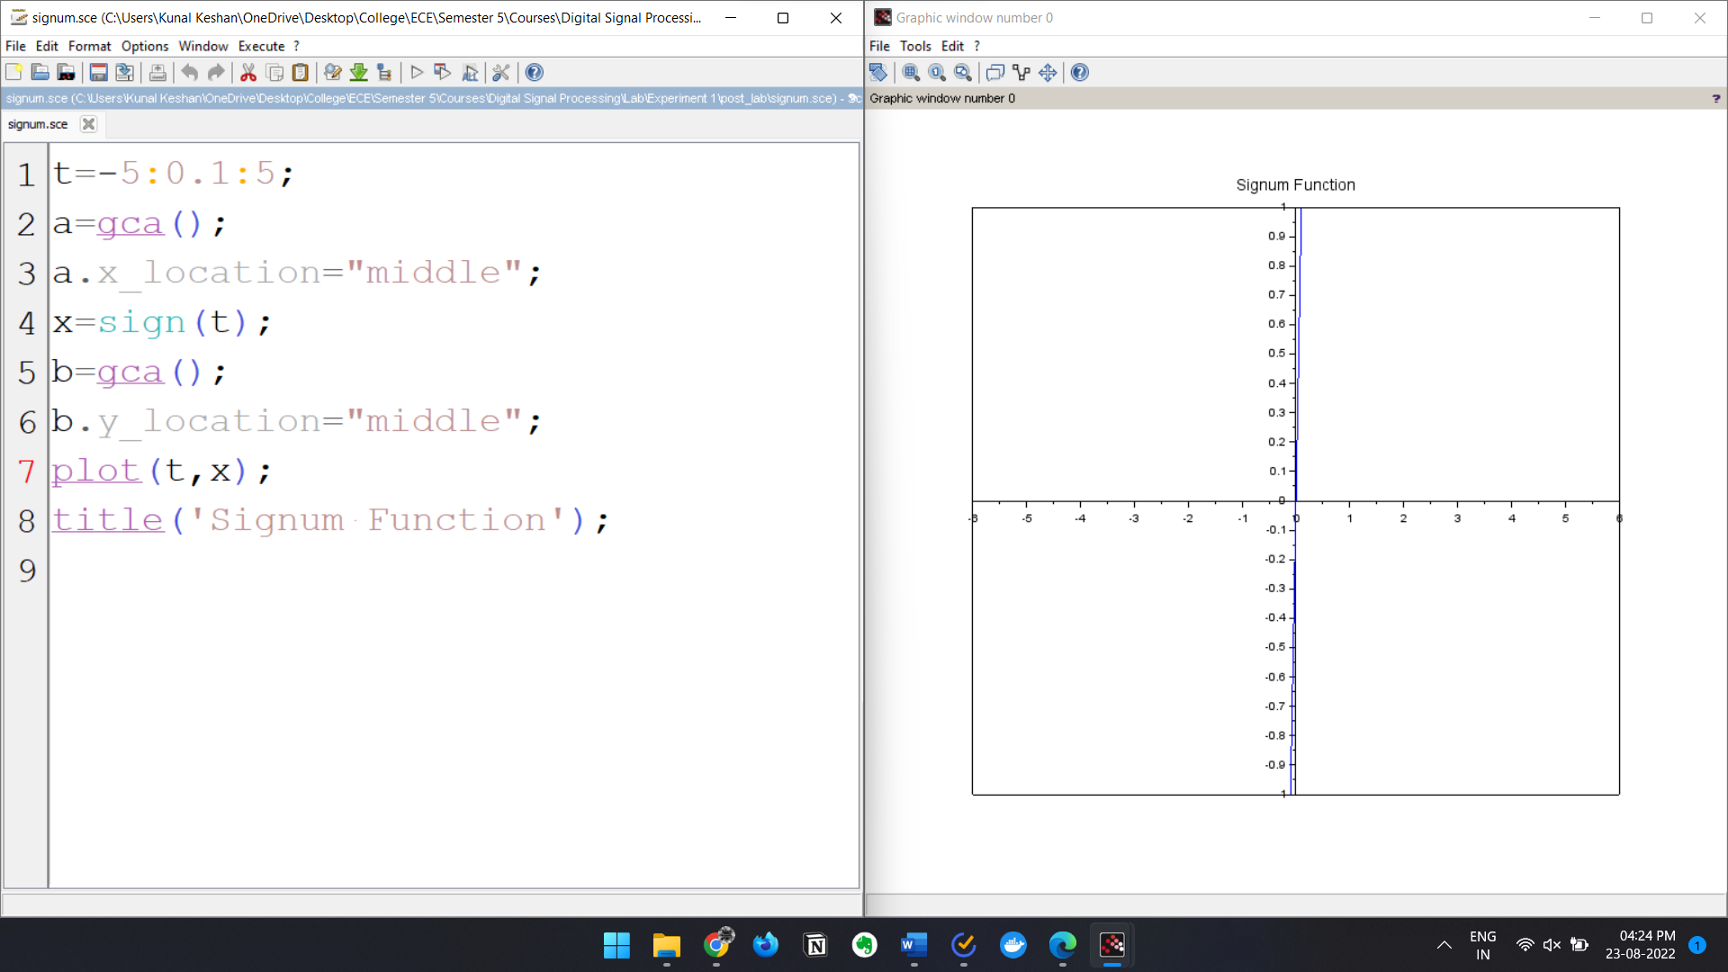

Derive the code and show the output for sinc function.

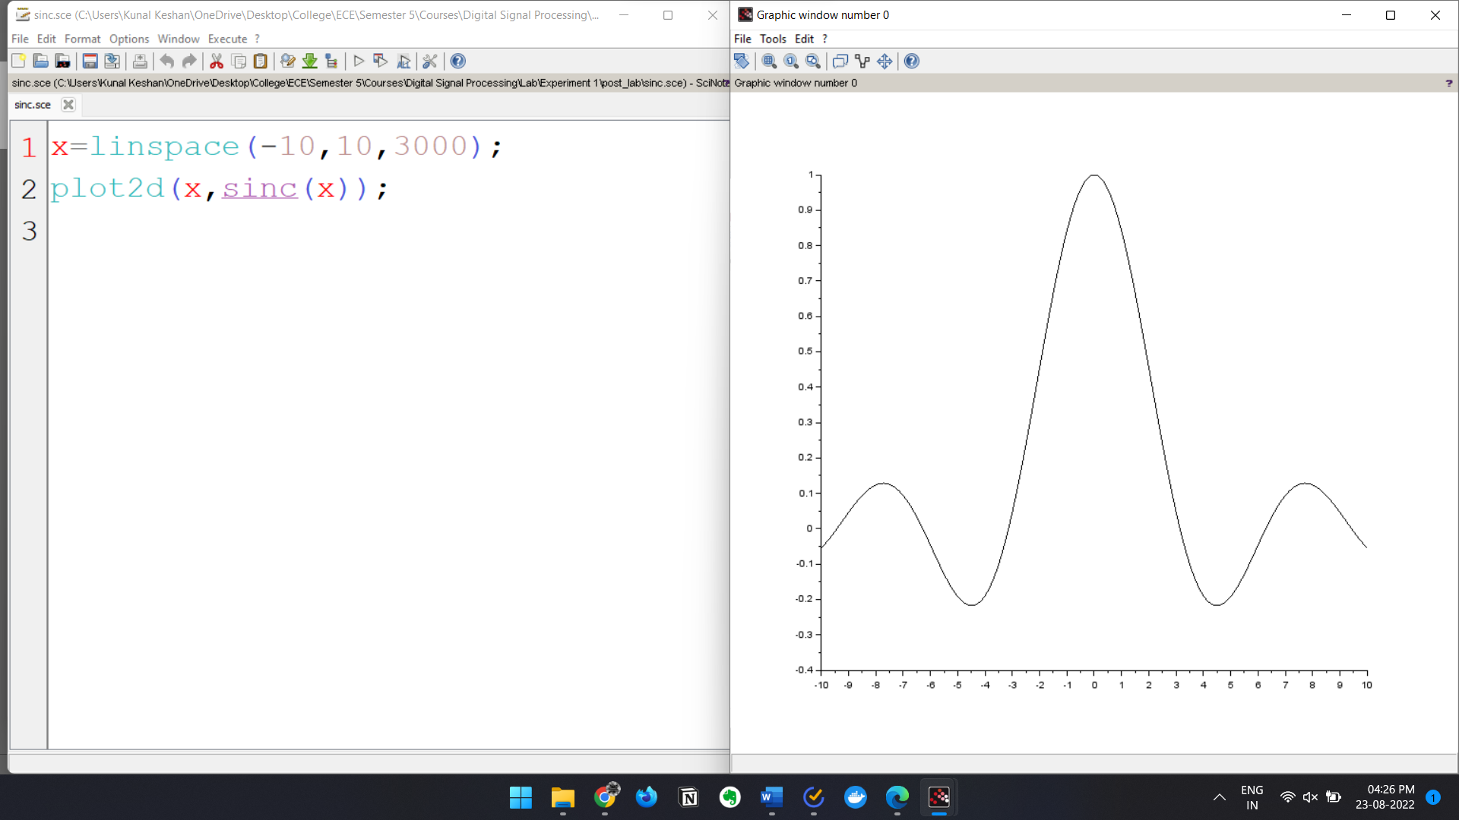

Derive the code and show the output for discrete exponential wave.

